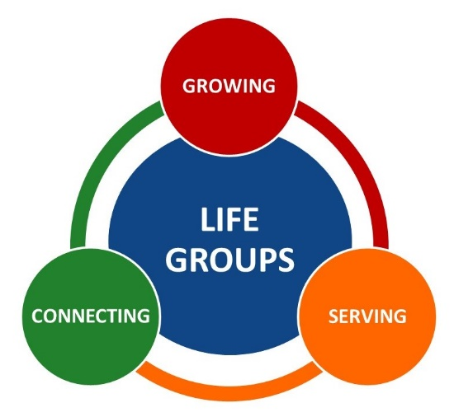

Sign Up Form

1. Full Name(s) (First & Last)
_____________________________________________________________________________
2. Home/Mobile Phone
_____________________________________________________________________________
3. Email Address
_____________________________________________________________________________
4. I'm filling this form out because I want to: (Circle one)
Join a Life Group
Lead a Life Group
5. Hobbies or interests
__________________________________________________________________________________________________________________________________________________________
6. What evenings are you available? (Circle day(s) that work best for you)
Monday Tuesday Wednesday Thursday Friday Saturday Sunday
7. Anything else you would like to tell us or ask?
__________________________________________________________________________________________________________________________________________________________
Completed forms can be given to Pastor Simon or put in mailbox #132

